

FPT ACADEMY INTERNATIONAL
FPT – APTECH COMPUTER EDUCATION

Installation Guide
iTech

eProject - Group 7 – T11907M0

I. System Requirement
No | Software | Description
1 | Operating system | Windows
2 | Hardware | Pentium 166 or better 64 Megabytes of RAM or better
3 | Software | Notepad, HTML editor, Dreamweaver, Netscape
4 | Web browser | Internet Explorer, Chrome, Firefox, etc

II. Instructions for downloading the source code
- Visit the link https://github.com/oOoIRISoOo/oOoIRISoOo.github.io. Then click on "Clone or download":
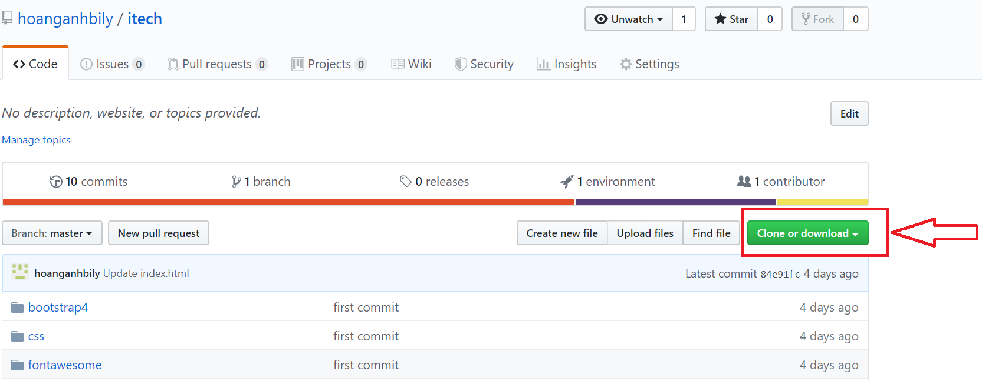
- Next choose “Download Zip”:
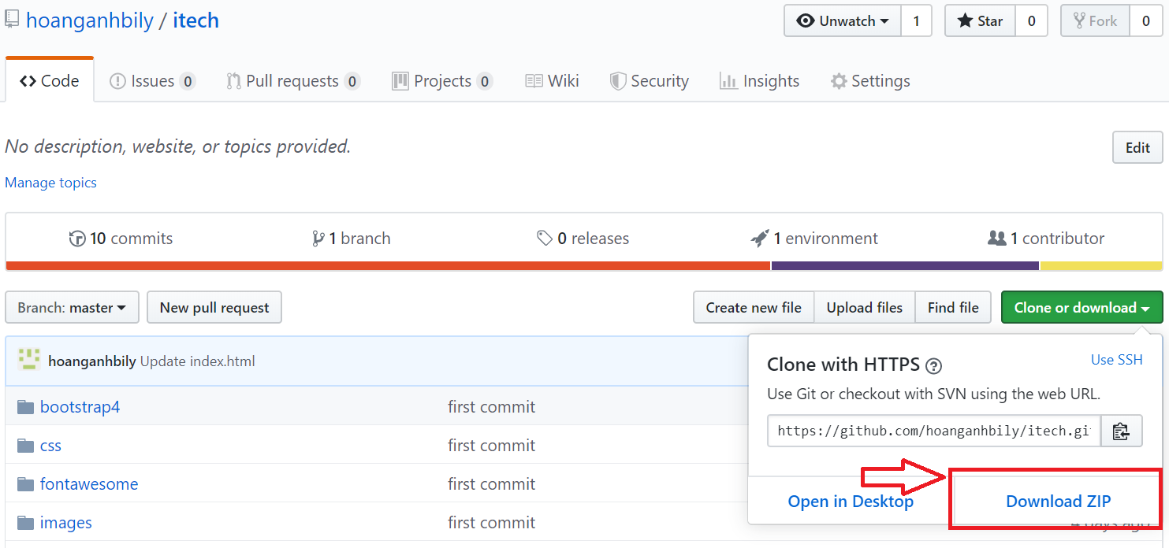
- Select the drive you want to save. Then extract the Zip file.

III. Test:
- Find index.html in E-project folder then run it on web browsers
- If the file is loaded successfully, homepage should be displayed as described in the documentation.




